Name & ID: SUALEH ABBAS & BURAIRA HAIDER Section:

Lab#02 DSB – SC Modulation and Demodulation

Objectives
- To design a balanced DSB_SC modulator using MC1496.
- To generate AM – Double Side Band Suppressed Carrier (DSB-SC) signal.
- Demodulate the modulated signal using rectifier detector.

Introduction

In the process of amplitude modulation, the modulated signal consists of the carrier wave and two sidebands. The modulated signal has the information only in the sidebands. Sidebands are nothing but a band of frequencies, containing power, which are the lower and higher frequencies of the carrier frequency. ^{[2]} The transmission of a signal, which contains a carrier along with two sidebands can be termed as Double Sideband Full Carrier system (DSB-FC). It is plotted as shown in the following figure.

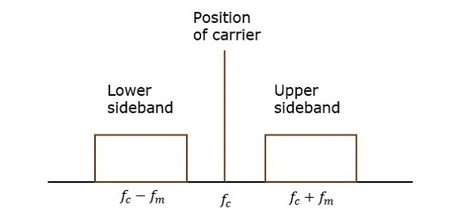
Figure 1: Double Sideband Full Carrier system (DSB-FC). ^{[2]}
However, such a transmission is inefficient. Because, two-thirds of the power is being wasted in the carrier, which carries no information. ^{[2]}

If this carrier is suppressed and the saved power is distributed to the two sidebands, then such a process is called as Double Sideband Suppressed Carrier system (DSB-SC). It is plotted as shown in the following figure.
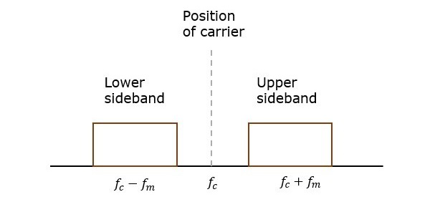
Figure 2: Double Sideband Suppressed Carrier system (DSB-SC). ^{[2]}

Balanced Modulator
Balanced modulator is used for generating DSB-SC signal. A balanced modulator consists of two standard amplitude modulators arranged in a balanced configuration so as to suppress the carrier wave. The two modulators are identical except the reversal of sign of the modulating signal applied to them. ^{[1]}
Modulation can also be achieved by using nonlinear devices, such as a semiconductor diode or a transistor. Figure 3 shows one possible scheme, which uses two identical nonlinear elements shown by boxes marked NL. ^{[1]}

Let the input-output characteristics of either of the nonlinear elements be approximated by a power series:
$$y\left(t\right)=ax\left(t\right)+bx^{2}\left(t\right) (1)$$

Where $x\left(t\right)$and$y\left(t\right)$ are the input and the output, respectively, of the nonlinear element. The summer output $z\left(t\right)$in Figure 3 is given by

$$z\left(t\right)=y_{1}\left(t\right)-y_{2}\left(t\right) (2)$$

$z\left(t\right)=[ax_{1}\left(t\right)+b{x_{1}}^{2}(t)]-[ax_{2}\left(t\right)+b{x_{2}}^{2}(t)]$ (3)

Substituting the two inputs $x_{1}\left(t\right)=\cos{ω_{c}t}+m(t)$ and $x_{2}\left(t\right)=\cos{ω_{c}t}-m(t)$ in this equation yields

$$z\left(t\right)=2am\left(t\right)-4bm\left(t\right)\cos{ω_{c}t} (4)$$

The spectrum of $m\left(t\right)$ is centered at the origin, whereas the spectrum of $m\left(t\right)\cos{ω_{c}t}$ is centered at
${±ω}_{c}$. Consequently, when $z\left(t\right)$ is passed through a bandpass filter tuned to$ω_{c}$ , the signal $am\left(t\right)$ is
suppressed and the desired modulated signal$4bm\left(t\right)\cos{ω_{c}t}$ passes through unharmed.^{[1]}

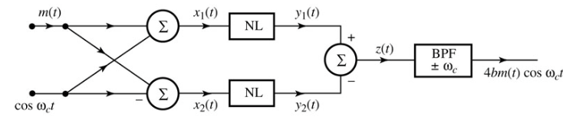
Figure 3: Nonlinear DSB-SC modulator. ^{[1]}

Demodulation of AM Signals
Like DSB-SC signals, the AM signal can be demodulated coherently by a locally generated carrier. Coherent, or synchronous, demodulation of AM, however, defeats the purpose of AM because it does not take advantage of the additional carrier component$A cos{ω_{c}t}$. As we have seen earlier, in the case of$μ ≤1$, the envelope of the AM signal follows the message signal$m\left(t\right)$. Hence, we shall consider here non-coherent method of AM demodulation under the condition of$0 < μ ≤1$: rectifier detection. ^{[1]}

Rectifier Detector: If an AM signal is applied to a diode and a resistor circuit, the negative part of the AM signal will be removed. The output across the resistor is a half wave rectified version of the AM signal. In essence, at the rectifier output, the AM signal is multiplied by$w\left(t\right)$. Hence, the half-wave-rectified output $v_{R}(t)$ is,

$${ v}_{R}\left(t\right)=\left\{\left[A+m\left(t\right)\right]\cos{ω_{c}t}\right\}w\left(t\right) (5)$$

$$v_{R}\left(t\right)=\left\{\left[A+m\left(t\right)\right]\cos{ω_{c}t}\right\}\left[\frac{1}{2}+\frac{2}{π} \left(\cos{ω_{c}t}-\frac{1}{3}\cos{3ω_{c}t}+\frac{1}{5}\cos{5ω_{c}t}-…\right)\right] (6)$$

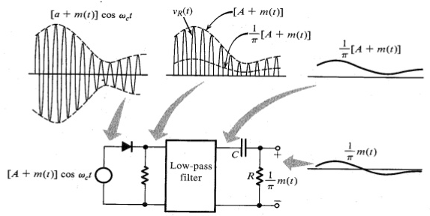
Figure 4: Rectifier detector for AM. ^{[1]}
$${ v}_{R}\left(t\right)=\frac{1}{π}\left[A+m\left(t\right)\right]+other terms of higher frequencies (7)$$

When $v_{R}(t)$ is applied to a low-pass filter of cutoff B Hz, the output is$[A + m(t)]/n$, and all the other terms in $v_{R}$ of frequencies higher than B Hz are suppressed. The dc term $A/n$ may be blocked by a capacitor to give the desired output$m(t) /n$ . The output can be doubled by using a full-wave rectifier. ^{[1]}

It is interesting to note that because of the multiplication with$w(t)$, rectifier detection is in effect synchronous detection performed without using a local carrier. The high carrier content in AM ensures that its zero crossings are periodic and the information about the frequency and phase of the carrier at the transmitter is built in to the AM signal itself. ^{[1]}

Experimental Work Apparatus Required

No. | Apparatus | Specifications | Quantity
1 | DC Power Supply | 0-30v,1A | 1
2 | Oscilloscope | 0-30 MHz | 1
3 | Function Generator | 1MHz | 1
4 | Breadboard | - | 1
Table 1: Apparatus required to perform this experiment

In Lab Tasks:

Task 1: Construct the circuit using a balanced modulator IC MC1496 for generation of Double Side Band Suppressed Carrier (DSB-SC) and analyze its output in time and frequency domain.

Components Required

No. | Components | Specifications / Values | Quantity
1 | Resistors | 51 ohms, 300 ohms, 1 k ohms,  3.9 k ohms, 6.8 k ohms 10 k ohms | 1, 1, 4,  2, 1, 2
2 | Capacitors | 0.1 uF | 4
3 | Potentiometer | 50 k ohms | 1
4 | Modulator IC | MC 1496 | 1
Table 2: Components required to perform In-Lab Task 1.

MC 1496 Pin Layout
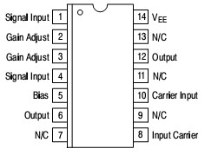
Figure 5: MC 1496 Pin Layout. ^{[3]}
The circuit of Figure 6 shows an AM balanced modulator circuit, whose carrier and message signals are single- ended inputs, carrier to pin 10 and message to pin 1. The gain of entire circuit is determined by the resistors value. The resistors determine the amount of bias current. Adjusting the amount of VR₁ or the message amplitude can change the percentage modulation.

Procedure

- Set up the circuit shown in Figure 6.
- Apply a sinusoidal signal of frequency 100 KHz and 100mVp-p as the carrier signal via Waveform button from FG.
- Apply a sinusoidal signal of frequency 1 KHz and 5 Vp-p(set by default in FG) as message signal using Mod button from FG.
- Now observe the AM output signal on oscilloscope.
- Adjust the VR₁ of AM modulator to get maximum amplitude of AM signal output (side bands) and suppress carrier by seeing the FFT spectrum at Output.
- Observe and record carrier signal, message signal, modulated signal and its spectrum waveforms in Table 4.
- Calculate modulation index for above case and show your calculations in below box.
u= (Emax-Emin)/(Emax+Emin) = (1.34-0.33)/(1.34+0.33) = 0.60

So modulation index is 60.47%

figure 6: Balanced Amplitude Modulator. ^{[3]}
Task 2: Demodulate a modulated signal by implementing a diode rectifier circuit.

Components Required

No. | Components | Specifications / Values | Quantity
1 | Resistors | 1 k ohms, 4.7 k ohms, 47k | 1, 1, 1
2 | Capacitors | 0.1 uF, 0.01 uF | 1, 1
3 | Germanium Diode | 1N34A | 1
Table 3: Components required to perform In-Lab Task 2
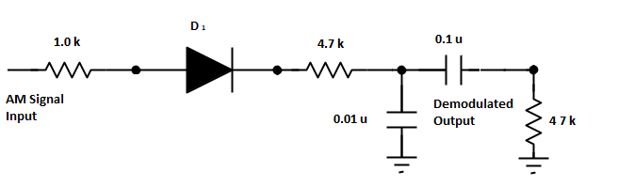
Figure 7: Rectifier detector circuit.
Figure 7 shows a practical rectifier detector circuit. The AM signal is rectified by diode and then fed into the input of the low-pass filter constructed using 4.7 k ohms resistor and 0.01 uF capacitor. The output signal of low- pass filter is the positive-half envelope with a dc level. The 0.1 uF capacitor is used to pass the ac components while blocking the dc component.

In-Lab Task 1 & 2: 100 kHz and 100mV_{pk-pk} carrier signal and 1 kHz and 5 V_{pk-pk} message signal

Table 4
Message Signal  Frequency _1k___  Amplitude __5.60_ | 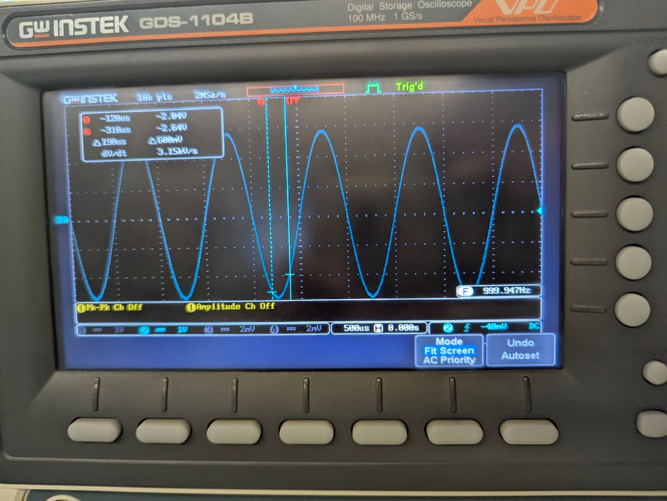
Carrier Signal  Frequency _99.98k_  Amplitude _200mV | 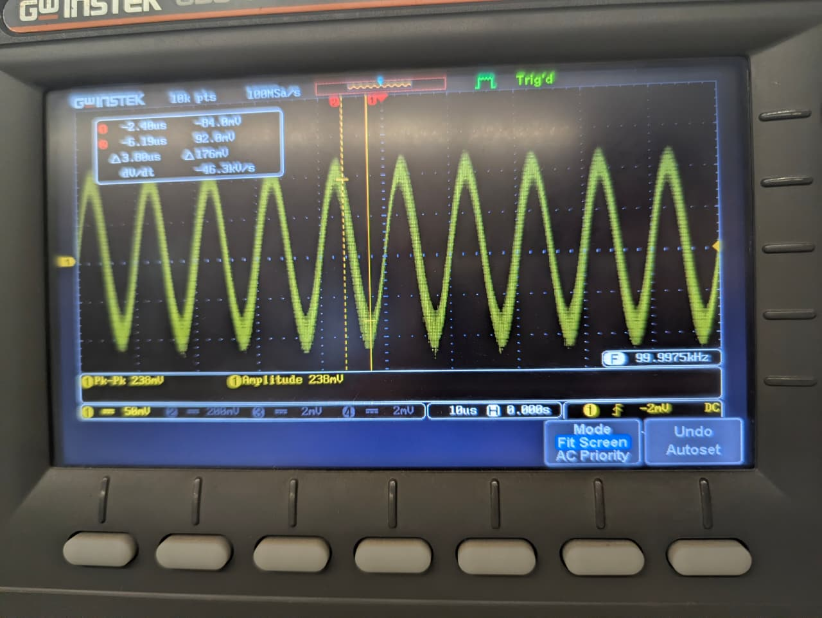
Modulated Signal  Amplitude _2.47V__  E_{max} __1.34V_  E_{min} _0.33V__ | 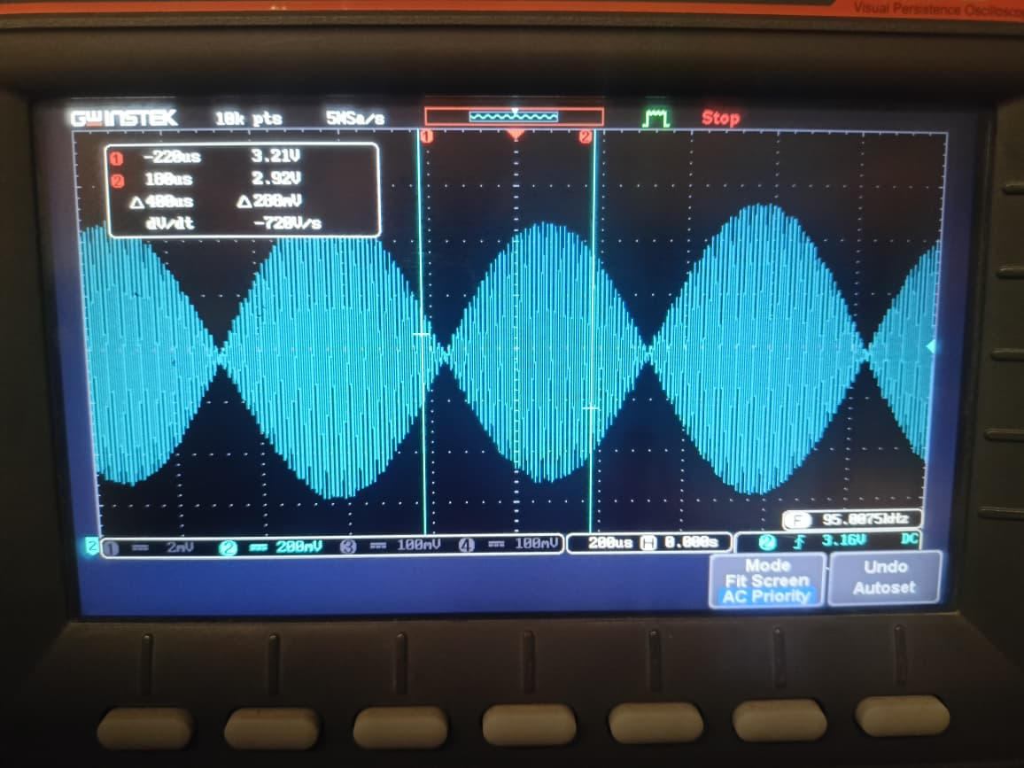
Spectra of DSB-SC  w_{LSB} _98.97k_  w_{USB} _100.97k_  BW __2k_ | 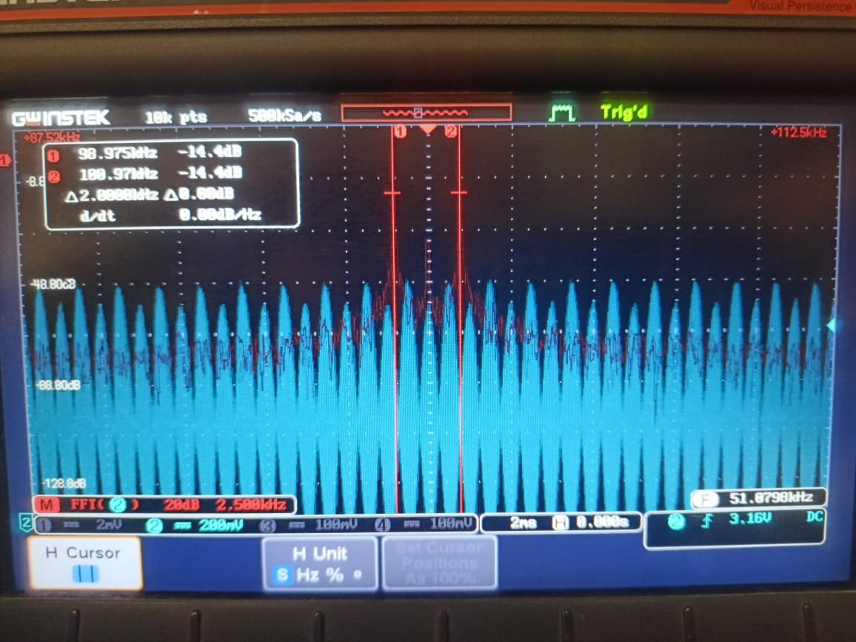
Demodulated Signal  Frequency______  Amplitude_______ | 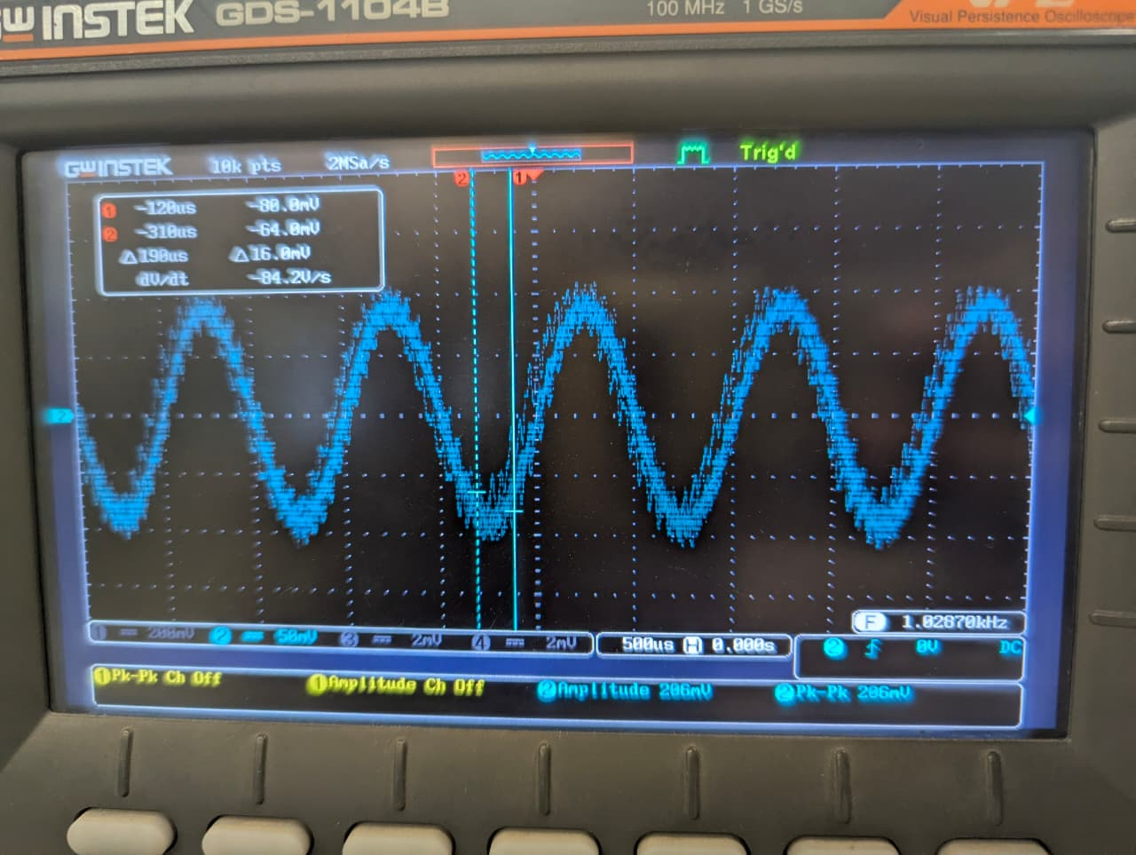

References
- B. P. Lathi and Z. Ding, Modern digital and analog communication systems, 4th Ed,
pg no. 151-157. New York: Oxford University Press, 2010.
- Tutorialspoint.com, “Analog Communication DSBSC Modulation,” www.tutorials-
point.com. [Online]. Available: https://www.tutorialspoint.com/analog_communic-
ation/analog_communication_dsbsc_modulation.htm. [Accessed: 31-May-2019].
- Datasheet, Balanced Amplitude Modulator IC MC1496, https://www.onsemi.com/
pub/Collateral/MC1496-D.PDF
- A. Bensky, “Communication Protocols and Modulation,” Short-range Wireless
Communication, pp. 75–117, 2004.44.

Name & ID:______________________________ Date: _____________


EE-322L Analog and Digital Communications Lab
Fall 2026
Habib University
Dhanani School of Science & Engineering

Lab#02 DSB – SC Modulation and Demodulation

Lab #2 Marks distribution:

 |  | LR1=30 | LR3=30 | LR5=10 | LR6=10 | AR4=20
In-Lab Tasks | Task 1 | /20 | /20 | /5 | /10 | /20
In-Lab Tasks | Task 2 | /10 | /10 | /5 | /10 | /20
Marks Obt. | /100
 | CLO2

Lab Evaluation Assessment Rubric
# | Assessment Elements | (0<Level 1<=4) | (4< Level 2<=6) | (6< Level 3<=8) | (8< Level 4<=10)
LR1 | Neat and Clean Circuit layout | Components are wired and didn’t show neat and clean connections and minimal efforts shown. | Components are wired with untidy connection and didn’t show neat and clean connections | Few but not all Components are wired with neat and clean connections | Complete components are wired with neat and clean tight connections. Given task completed in due time.
LR3 | Troubleshooting | Unable to identify the fault/minimal effort shown | Able to identify the fault but unable to remove it. | Able to identify the fault but partially removes it. | Able to identify the fault and able to make necessary steps and actions to correct it.
LR5 | Results & Plots | Figures, graphs, tables contain errors or are poorly constructed, have missing titles, captions, units missing or incorrect, etc. | Most figures, graphs, tables OK, some still missing some important or required features | All figures, graphs, tables are correctly drawn, but some have minor problems or could still be improved | All figures, graphs, tables are correctly drawn and contain titles/captions.
LR6 | Clean-up | All equipment/PC is not powered off.  All items left at station and not cleaned. | Many equipment/PC is not powered off.  Many items left at station. | Some equipment/PC is not powered off.  Some items left at station. | All equipment/PC is powered off.  Station left neat and clean.
AR4 | *Report Submission | Late submission after 1 week. | Late submission after 4 days and within a week. | Late submission after the lab timing and after 2 days of the due date. | Timely submission of the report and in lab time.

*Report: Report will not be accepted after 1 week of due date

